**Lab: Reflected XSS into HTML context with most tags and attributes blocked**

Problem: in the search functionality but uses a web application firewall (WAF) to protect against common XSS vectors.

Goal: perform a [cross-site scripting](https://portswigger.net/web-security/cross-site-scripting) attack that bypasses the WAF and calls the print() function.

Solution:

1-

2-dosen’t work

3-

4-

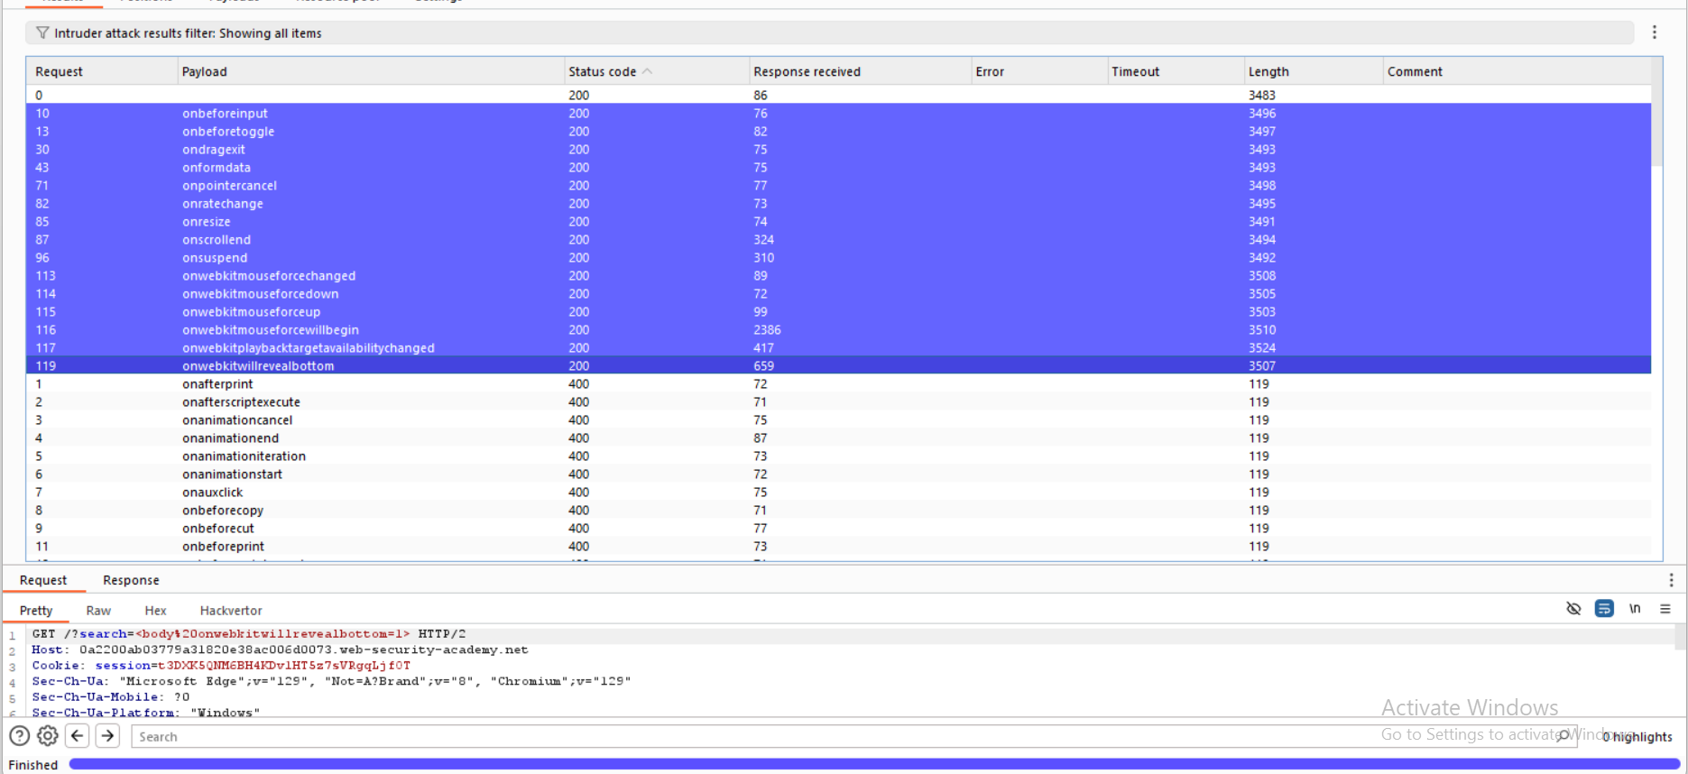

5-

